MINISTRY OF SCIENCE AND EDUCATION NATIONAL TECHNICAL UNIVERSITY “KHARKIV POLYTECHNIC INSTITUTE”

DEPARTMENT OF SOFTWARE ENGINEERING AND MANAGEMENT INFORMATION TECHNOLOGIES

Report from lab#7

Discipline “Software Architecture ”

Executed by: Student of group 1.КН201.8ei1

CHUKWU IRELE AMORIN

Checked by:

Prof. Khtasko

Task : components diagram

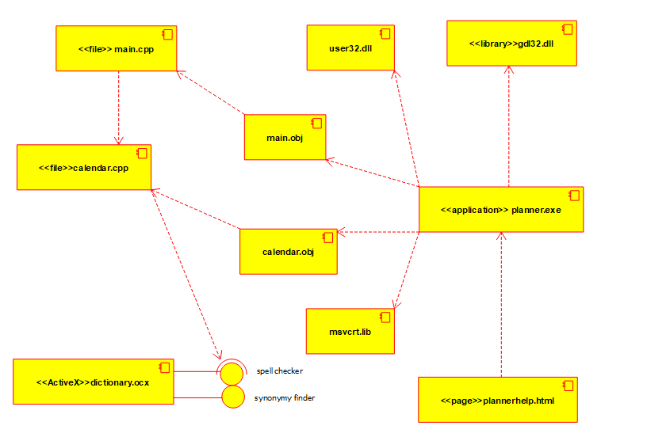

Planner Application:

This is a **“Planner Application”** component diagram, it show all the dependencies associated with this application, the libs, the executables, the dll and the code files.

It also shows the connection and relationship between each components.

A component diagram shows the structure of the code: the dependencies among software components. Components can be source code components (java, h, cpp ...), executable components (exe ...), libraries (dll, lib, class ...), etc.